**EXAMPLE 9.11**

*Ho*: *μ* = 5, *Ha*: *μ* < 5

Test of a single population mean. *Ha* tells you the test is left-tailed. The picture of the *p*-value is as follows:

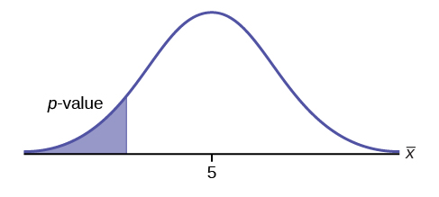

*H0*: *p* ≤ 0.2  *Ha*: *p* > 0.2

This is a test of a single population proportion. *Ha* tells you the test is **right-tailed**. The picture of the *p*-value is as follows:

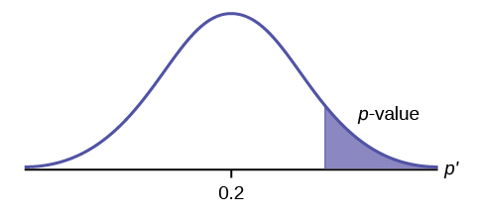

*H0*: *p* = 50  *Ha*: *p* ≠ 50

This is a test of a single population mean. *Ha* tells you the test is **two-tailed**. The picture of the *p*-value is as follows.

